Assignment: 1
Module -1: Understanding of Hardware and Its Components
_{Section 1: Multiple Choice}
- Which of the following is NOT a component of the CPU?
- _{ALU}
- _{RAM}
- _{CU}
- _{A and C both}
Answer: B. RAM
- What is the function of RAM in a computer?
Answer: RAM stores data temporarily and provides fast access for
CPU.
- Which of the following is a primary storage device?
  - HDD
  - SSD
  - SD card
  - A and B both
Answer: C. SD card
- What is the purpose of a GPU?
Answer: A GPU’s main purpose is to process and display graphics
quickly and efficiently.

Section 2: True or False
- True or False: The motherboard is the main circuit board of a computer where other components are attached.
Answer: True
- True or False: A UPS (Uninterruptible Power Supply) is a hardware device.
Answer: True
- that provides emergency power to a load when the input power source fails.
Answer: True

- True or False: An expansion card is a circuit board that enhances the functionality of a component.
Answer: True

Section 3: Short Answer
- Explain the difference between HDD and SDD
- HDD: Uses spinning disk to store data, slower, cheaper, more storage capacity.
- SDD: Uses flash memory, much faster, more durable, costlier.
- Describe the function of BIOS in a computer system.
- BIOS Issue the instructions for starting the hardware at boot time.
Load the OS from the boot device.
- List and briefly explain three input devices commonly used with computers.
- Scanner: A scanner allows you to scan documents, Pictures, or graphics and view them on the computer.

- Microphone: Used to input sound into a computer.

- Keyboard: used for typing text and commands.

Section 4: Practical Application

Identify and label the following components on a diagram of a motherboard:
● CPU
● RAM slots
● SATA connectors
● PCI-E slot

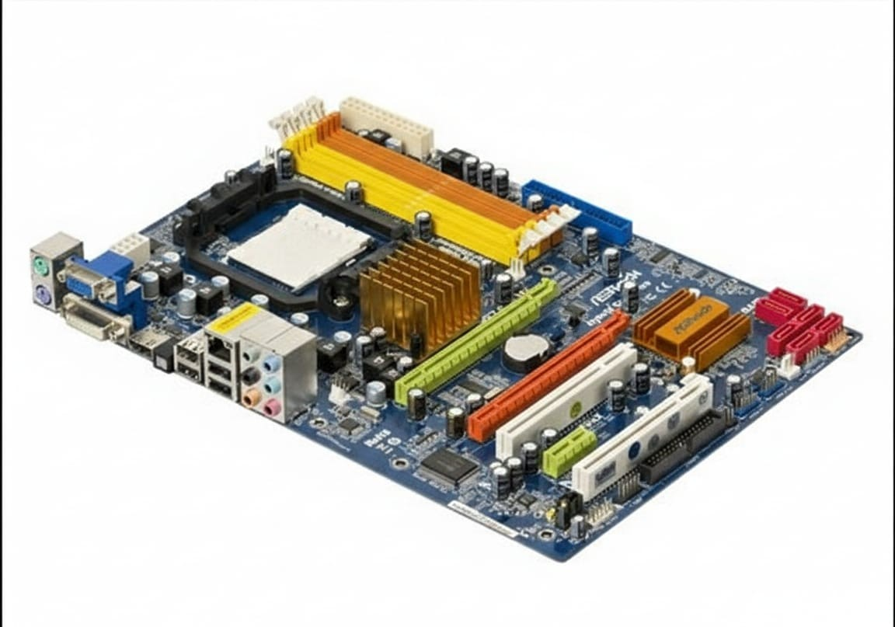

CPU
PCI-E SLOTS
RAM SLOTS
SATA connecter

12. Demonstrate how to install a RAM module into a computer.
- Installing a RAM Module into a Computer

- Steps to install RAM:
- Turn off the computer
  - Shut down the system completely.
  - Unplug the power cable from the socket.
- Open the computer cabinet
  - Remove the side panel using a screwdriver .
- Locate the RAM slots
  - Find the long, narrow RAM slots on the motherboard.

- Open the RAM slot clips
  - Push the plastic clips at both ends of the slot outward.
- Align the RAM module
  - Match the notch on the RAM with the notch in the RAM slot.
  - RAM fits only in one direction.
- Insert the RAM module
  - Press the RAM firmly into the slot using both thumbs.
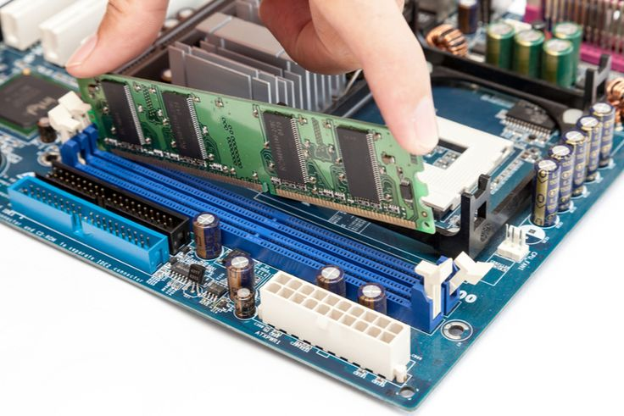

  - The clips will automatically lock into place.
- Close the cabinet
  - Replace the side panel and tighten the screws.
- Power on the computer
  - Plug in the power cable and turn on the system.
  - Check if the system detects the new RAM.

Section 5: Essay

13. Discuss the importance of proper cooling mechanisms in a computer system. Include examples of cooling methods and their effectiveness.
- A computer system produces heat when it is working.
- Main parts like CPU, GPU, RAM, and power supply generate heat.
- If heat is not controlled, the system may overheat.
Why cooling is important
- Prevents damage to hardware
- Improves performance and speed
- Increases life span of components
- Prevents system crashes and shutdowns
Cooling Methods
- Air Cooling
  - Uses fans and heat sinks
  - Cheap and easy to use
  - Common in personal computers
- Liquid Cooling
  - Uses liquid to absorb and remove heat
  - More effective than air cooling
  - Used in gaming PCs and servers
- Passive Cooling
  - Uses heat sinks only (no fans)
  - Silent but less effective
  - Used in low-power devices
Conclusion
- Proper cooling is necessary for safe and efficient working of a computer system.

14. Concept of Bus Width and Its Significance in Computer Architecture
- Bus width means the number of bits a bus can carry at one time.
- It connects components like CPU, memory, and input/output devices.
Explanation
- A 32-bit bus can transfer 32 bits at once.
- A 64-bit bus can transfer 64 bits at once.
- Wider bus = more data transfer at a time
Significance of Bus Width
- Increases data transfer speed
- Improves system performance
- Supports more memory
- Helps in running modern applications smoothly
Conclusion
- Bus width plays an important role in making the computer faster and more efficient.

